Name : Parth Wankhede
PRN : 25070521159
6.1.1] Incremented Date

A) ALGORITHM
- Start. s
- Read day.
- Read month.
- Read year.
- If year ≤ 0, print "Invalid Date" and Stop.
- If month < 1 or month > 12, print "Invalid Date" and Stop.
- If month is 1, 3, 5, 7, 8, 10, 12 then max_days = 31.
- Else if month is 4, 6, 9, 11 then max_days = 30.
- Else if month is 2:
If (year % 400 == 0) OR (year % 4 == 0 AND year % 100 ≠ 0) max_days = 29 Else max_days = 28
- If day < 1 or day > max_days, print "Invalid Date" and Stop. 11. If day < max_days then day = day + 1. 12. Else day = 1 If month == 12
month = 1 year = year + 1 Else month = month + 1
- Print day-month-year in format DD-MM-YYYY.
- Stop.

B) PYTHON CODE
day = int(input()) month = int(input()) year = int(input())

def is_leap(year): if (year % 400 == 0) or (year % 4 == 0 and year % 100 != 0):
return True return False

def days_in_month(month, year): if month in [1, 3, 5, 7, 8, 10, 12]: return 31 elif month
in [4, 6, 9, 11]: return 30 elif month == 2:
return 29 if is_leap(year) else 28
else: return 0

if year <= 0 or month < 1 or month > 12: print("Invalid Date") elif day < 1 or day > days_in_month(month, year):
print("Invalid Date") else: day += 1 if day > days_in_month(month, year):
day = 1 month += 1 if month > 12: month = 1 year += 1
print(f"{day:02d}-{month:02d}-{year}")

FLOWCHART
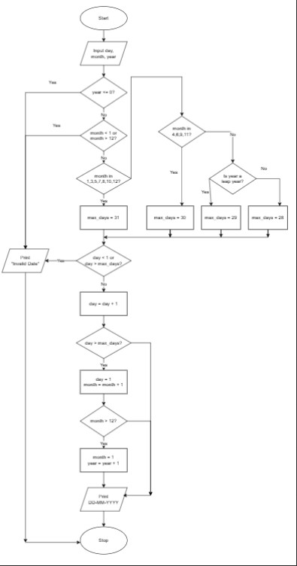

D) EXCECUTION

